Student’s name | …………………………………………………….…… | Grade | 6
Subject | Computer | Week No. | 7
Lesson Title | Build and App | Unit
Worksheet No. ( 7 )
Question A: In the Designer sector, we design the functionality of the components.
a. True b. False


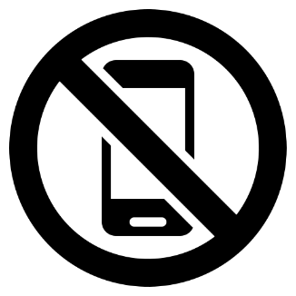


Question B: write the correct name of each part
Wash Hands
No Call Phone
Shopping Cart
Gift
Good Luck

